CORONAVIRUS IN PAKISTAN

##### 72,460

##### 72,460

###### Dial 1166 for health helpline

###### logo

###### Confirmed Cases Case’s (24 HRS) Deaths (24 HRS) Tests (24 HRS) Total Tests

#### **85,856 4,896 68 22,812 638,323**

 **Deaths Recovered Sindh Punjab KPK Islamabad Baluchistan AJK/GB**

###### 1,838 31,198 33,536 33,144 11,890 3,946 5,582 299/852

## Corona Virus SYmtons

It can take up to 14 days for symptoms of coronavirus to appear. The main symptoms to look out for are:

### Coughing http://covid.gov.pk/theme_img/icons/w1.png Shortness of Breath http://covid.gov.pk/theme_img/icons/w3.png

### Fever http://covid.gov.pk/theme_img/icons/w4.png image Sore Throat http://covid.gov.pk/theme_img/icons/w5.png

**Precautions**

#### **Ways to prevent the disease:**

### [Wash Your Hands for 20sec](http://covid.gov.pk/)

Wash hands often with soap and water for at least 20 seconds.

### [Cover Nose & Mouth When Sneezing](http://covid.gov.pk/)

Cover coughs and sneezes with tissues.

### [Use Sanitizer](http://covid.gov.pk/)

Use hand sanitizer if soap and water are not available.

### [Avoid Crowded Places (Social Distancing)](http://covid.gov.pk/)

As an individual, you can lower your risk of infection by reducing your rate of contact with other people. Avoiding public spaces and unnecessary social gatherings, especially events with large numbers of people or crowds, will lower the chance that you will be exposed to the coronavirus as well as to other infectious diseases like flu.

### [Avoid Contact with Sick People](http://covid.gov.pk/)

Avoid close contact with anyone showing symptoms of respiratory illness.

**COVID-19 Visualization using Tableau Public**

Coronavirus disease (COVID-19) is an infectious disease caused by a newly discovered coronavirus. Most people infected with the COVID-19 virus will experience mild to moderate respiratory illness and recover without requiring special treatment.  Older people and those with underlying medical problems like cardiovascular disease, diabetes, chronic respiratory disease, and cancer are more likely to develop serious illness. The best way to prevent and slow down transmission is be well informed about the COVID-19 virus, the disease it causes and how it spreads. Protect yourself and others from infection by washing your hands or using an alcohol based rub frequently and not touching your face. The COVID-19 virus spreads primarily through droplets of saliva or discharge from the nose when an infected person coughs or sneezes, so it’s important that you also practice respiratory etiquette (for example, by coughing into a flexed elbow). At this time, there are no specific vaccines or treatments for COVID-19. However, there are many ongoing clinical trials evaluating potential treatments. WHO will continue to provide updated information as soon as clinical findings become available?

Using Tableau Public we can analyze and visualizes COVID-19 data to keep the communities informed at the city, provincial and country level. While making these visualization with Tableau Public it is very helpful to solves my problem of data cleaning and as well as regarding dataset some data was irregular so we modified it. The beauty of Tableau Public is how easy it is to make something visually appealing and neat with limited creativity. Drag-and-drop functionality, easy resizing, copying and pasting makes those who are familiar with the Microsoft Office suite feel right at home.

**Visualization 01**

In this visualization we are discussing cumulative test performed and cumulative test positive (+ve) across all regions of Pakistan. According to this survey region of Punjab is on the top having more cases of Corona Virus and AJK is on the bottom having less cases.

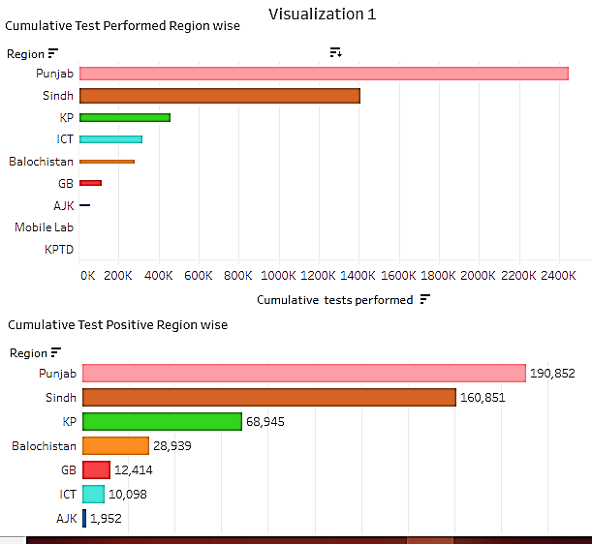

**Visualization 02**

In this visualization we are dealing with the cumulative, discharge and expired cases of COVID-19 across all regions of Pakistan. Punjab is on the top having **1,595,291** cumulative, **54,158** discharged and **2,826** expired cases and AJK is on the bottom having **55,970** cumulative, **675** discharged and **0(zero)** expired cases.

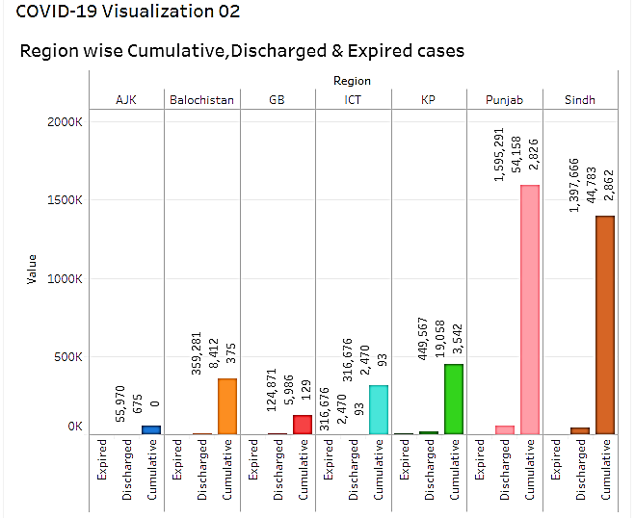

**Visualization 03**

In this visualization we are discussing total Cumulative cases all over Pakistan from **11 March 2020** to **10 May 2020**

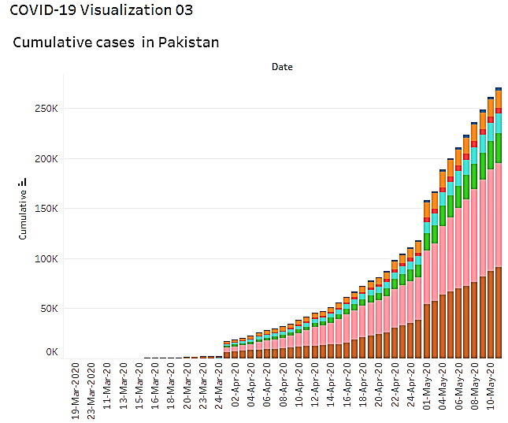

**Visualization 04**

In this visualization we are discussing Cumulative death cases and province wise last 24 hours death cases of COVID-19 across all over Pakistan. In this survey Punjab is on the top having highest death rate over all other provinces of Pakistan

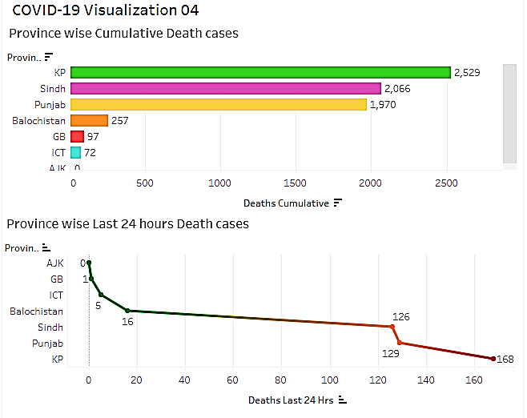

**Visualization 05**

In this visualization, we are discussing cumulative travelers screened and suspected travelers at the point of entry which are arrived from different countries from all over world. Mostly travelers are arrived from China and Iran having highest rate of Coronavirus victims.

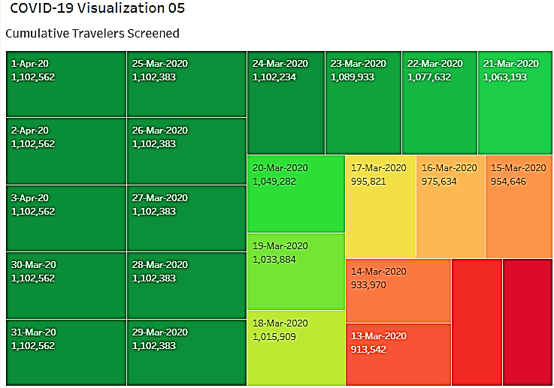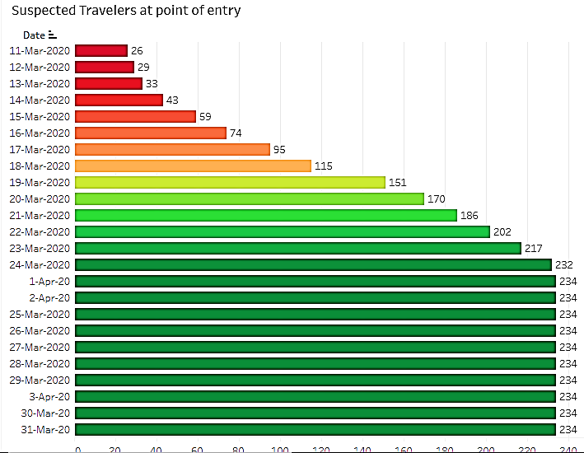

**Visualization 06**

In this visualization, we are discussing Province-wise cumulative & confirmed cases during the last 24hrs cases and Province-wise deaths cumulative and deaths during the last 24hrs case. According to this survey, the province of Punjab is on the top having highest rate of both.

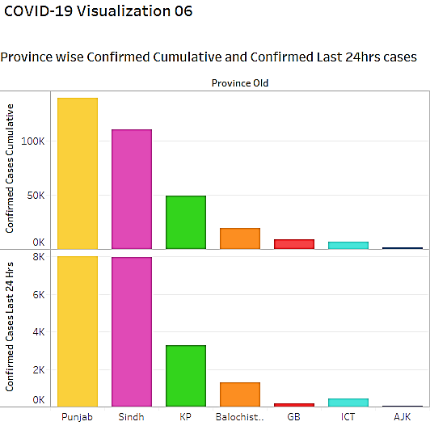 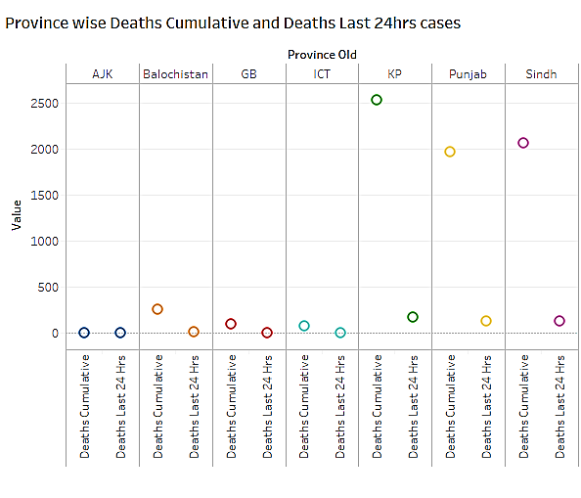

**Visualization 07**

In this visualization, we are discussing province-wise facilities available for Corona patients. According to the graph Sindh and KPK is on the top having highest rate of facilities available.

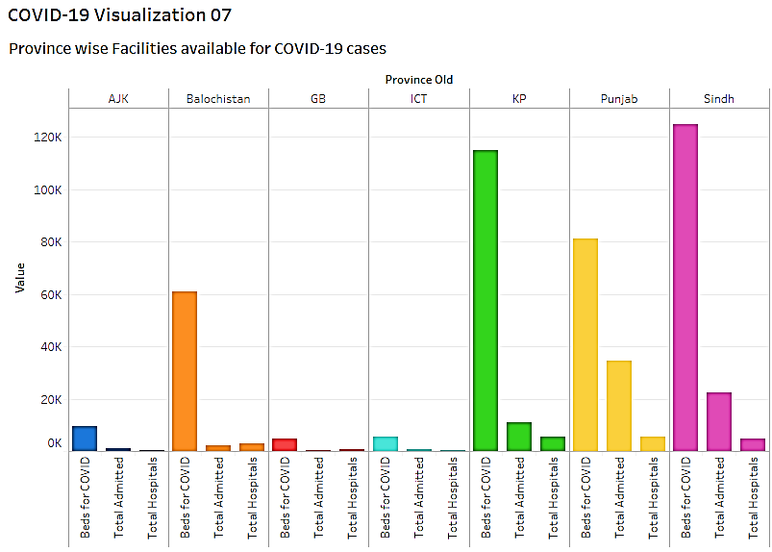

**Visualization 08**

In this visualization, we are discussing the province’s having Quarantine facilities for COVID-19 patients. The province of KPK, GB and AJK have the highest rate of Quarantine facilities.

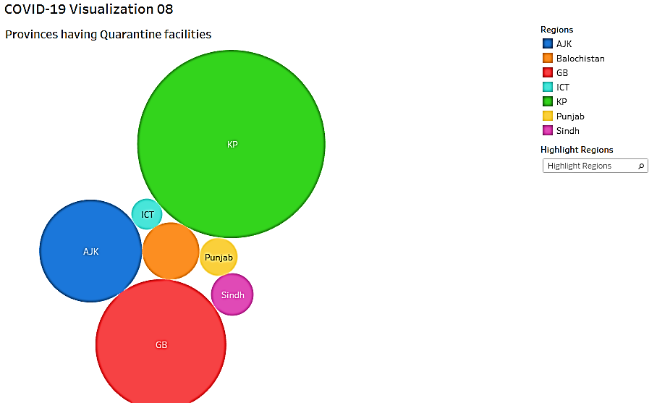

**Visualization 09**

In this visualization, we are discussing returnees under self-quarantine. The returnees from China and Iran are under self-quarantine from **11 March 2020** to **30 March 2020**

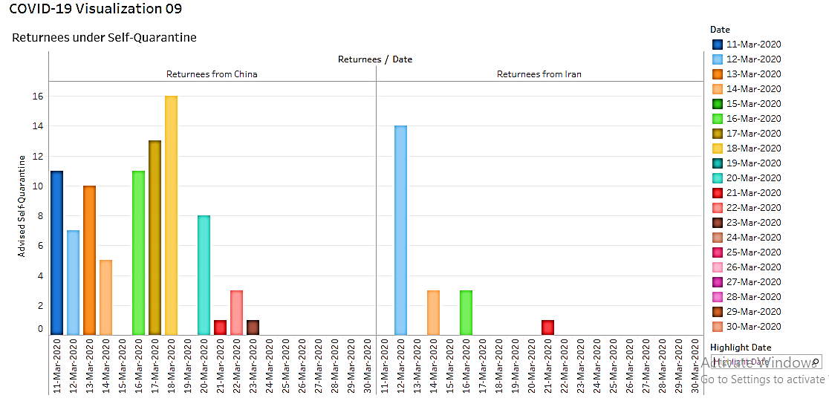

**Visualization 10**

In this visualization we are discussing cumulative calls by people to different helplines under the duration from **11 March 2020** to **2 April 2020**

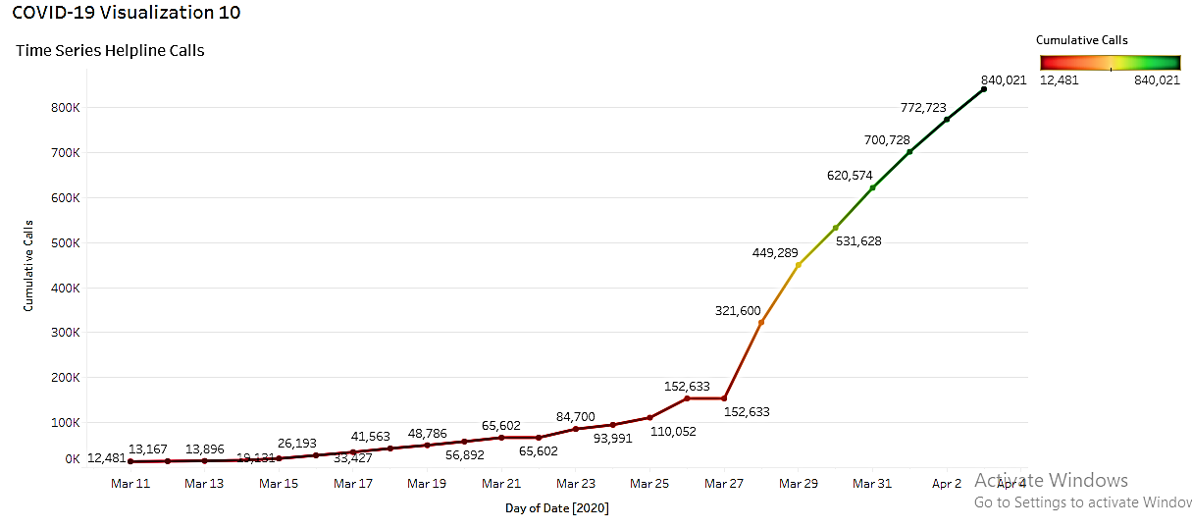

**We are here to help you**

## Frequently Asked Questions!

* **What is isolation?**

Separation of the affected person or suspected of being infected from other healthy people for the duration of the disease infection in appropriate places and health conditions, in order to prevent the transmission of the infection.

* **What is the difference between isolation and quarantine?**

Isolation and quarantine are common public health strategies used to help prevent the spread of infectious diseases. Isolation and quarantine keep people who are sick or exposed to illness isolated for a defined period of time to prevent the disease spread.

* **Why this prevention important for me?**

You may be asked to:

Stay at home

Stay away from others

Ensure that there are no symptoms of the disease

Contact the doctor if you develop symptoms

* **Does isolation and quarantine prevent infection of others?**

Quarantine and isolation are effective measures that are taken to reduce the spread of the disease to all members of society.

* **What is Quarantine?**

Restricting the activities of healthy people for a period of time as determined by the competent medical authorities.